**PHP e-Project**

***Online Shopping Cart***

**Submitted To**

[eprojects@aptech.ac.in](mailto:eprojects@aptech.ac.in)

**Project Instructor**

Miss Tehreem Mushtaq

**Curriculum Code**

6740

**Group Members**

*Abdalullah Sheikh*

*Student1286264*

*Ahmad Zafer  
Student1286650*

*Abdul Mueed  
Student1291743*

*Kashan Ahmad   
Student1285717*

*Tameem Shaikh  
Student1274626*

# *Online Shopping Cart*



**By Clicking on that button you will reach the**

**appropriate site. This is Service Site……**

Set

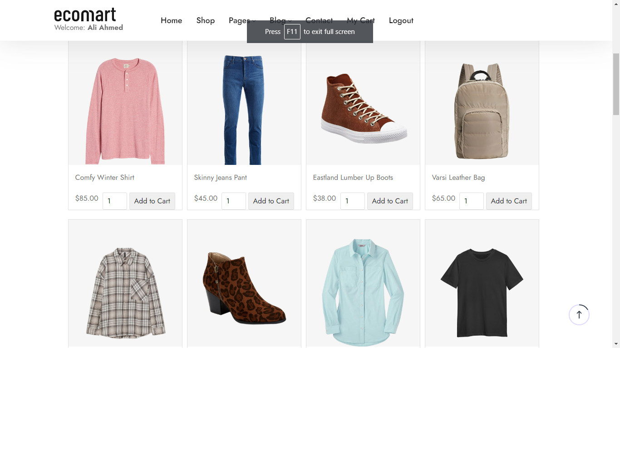

Eastland Lumber Up Boots, Soft Touch Interlock Polo, Cotton Shirt For Men, Ribbed Cotton Rope, Men’s Tricat track Jacket, Men’s Classic Fit Polo E.C.T

FOR MEN AND BOYS

Comfy Winter Shirt, Skinny Jeans Pant, Fit Twill Shirt For Women, Grand Atlantic Chukka Boots, Women’s Faux-Trim Shirt E.C.T

FOR WOMEN AND GIRLS

SHOP

Varsi Leather Bag, Ecomart Smart Watch, Smart Glass, Diamond Ring, Tinted Sunglasses, Polarzied Sunglasses

ACCESSORIES

**HOME PAGE:**

CLICK ON "HOME" PAGE & HOME PAGE WILL BE APPEAR……

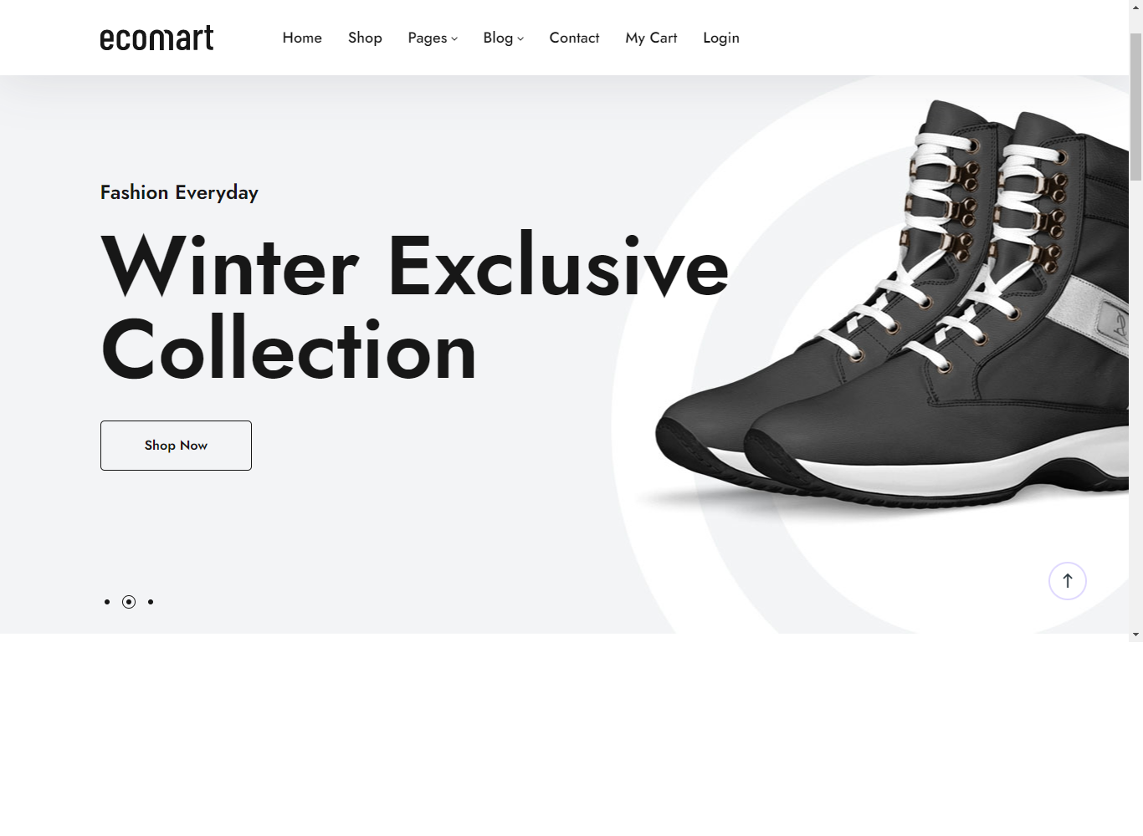

**CONTACT US PAGE:**

CLICK ON "CONTACT US" PAGE & PAGE WILL BE APPEAR……

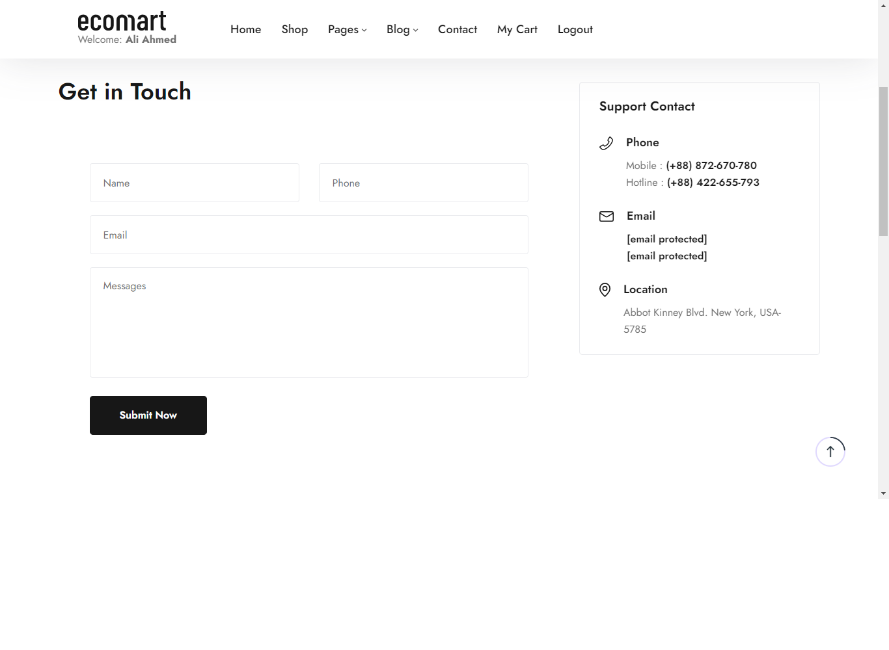

**LOGIN PAGE:**

